Oliver Collins-Cope

2102775@rutc.ac.uk

Learning Aim B & C

Design 2D and 3D digital graphics products to meet  
a client brief & Develop 2D and 3D digital graphics products to meet a  
client brief.

Unit 17 2D And 3D Graphics

Assignment 2

Contents

Introduction 2

Design 2

2D Design 4

3D Design 5

Assets used 5

Design justification 6

Evaluation 7

Feedback 7

Changes made based on feedback 15

Developing graphics 16

2D Graphic 16

2D Optimisation 17

3D Graphic 21

3D Optimisation 25

Evaluation of Graphics 30

2D Evaluation against brief 30

3D Evaluation against brief 31

# Introduction

# Design

Throughout this section I will document the design of the overall graphic and also display the specific section for the 2D Graphic and 3D Graphic.

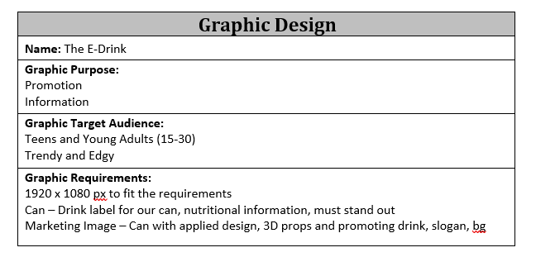

This displays the overall beginning of the design, ranging from the drinks name to the graphic requirements, such as 1920x1080 image. This helps to outline the direction that my drink should take in order to be successful from the client brief.

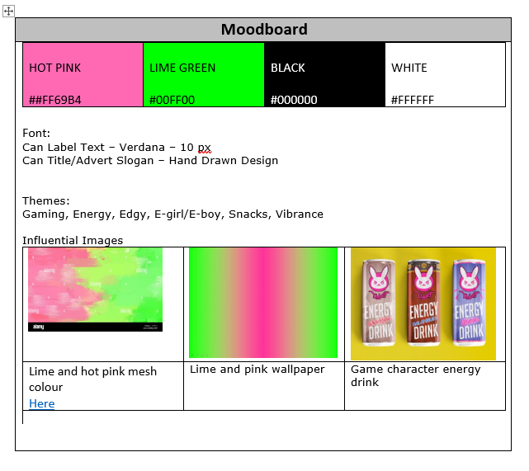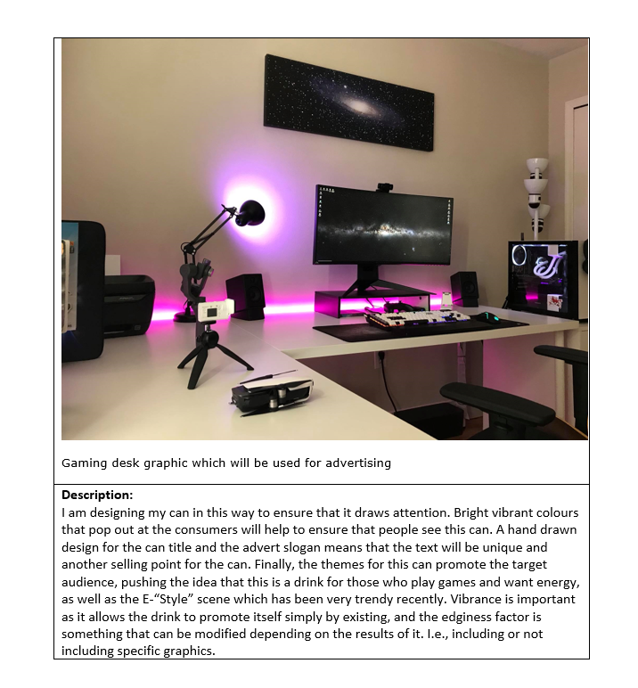

Here is the Moodboard that includes information about the design choices made here in order to ensure that the drink is successful once it is made and launched.

The text is included below:

“I am designing my can in this way to ensure that it draws attention. Bright vibrant colours that pop out at the consumers will help to ensure that people see this can. A hand drawn design for the can title and the advert slogan means that the text will be unique and another selling point for the can. Finally, the themes for this can promote the target audience, pushing the idea that this is a drink for those who play games and want energy, as well as the E-“Style” scene which has been very trendy recently. Vibrance is important as it allows the drink to promote itself simply by existing, and the edginess factor is something that can be modified depending on the results of it. I.e., including or not including specific graphics.”

## 2D Design

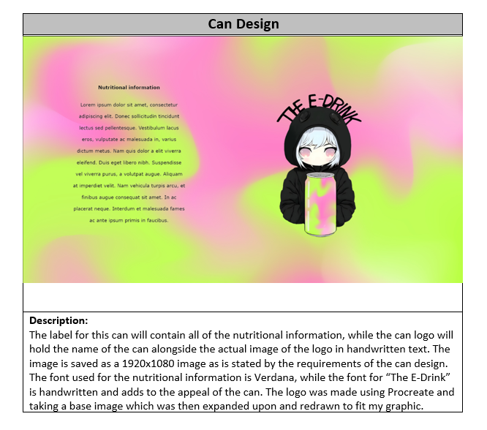

This is the initial design for the can that will be used. This is to be displayed the can and will contain all the nutritional information, while maintaining the colour and vibrant theme of the drink.

## 3D Design

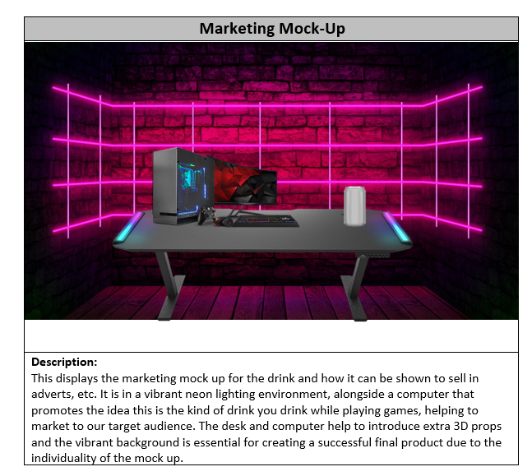

This is the initial 3D design made inside of a 2D image. It displays how the drink is supposed to stand on the table while near a gaming pc, promoting the idea that the drink is supposed to be drunk while playing video games.

## Assets used

Below is the list of assets used to create the 2D and 3D designs:

[marketing back ground mock up](https://pngtree.com/back/down?id=MTIyNjczNA==&type=1&time=1681931483&token=ZTQ5YjY3NzVkMzZjNTdkY2E5ZTY1ZTlkMmU2YjdkOTE=)

[original chibi image logo](https://www.google.com/url?sa=i&url=https%3A%2F%2Fwww.redbubble.com%2Fi%2Fposter%2FChibi-Anime-Girl-Drinking-Boba-Milk-Tea-Kawaii-by-Nymmzi%2F137657908.LVTDI&psig=AOvVaw3WMxFmCnF1xW1EmI0MQHby&ust=1682013907988000&source=images&cd=vfe&ved=0CBAQjRxqFwoTCOiTk57Etv4CFQAAAAAdAAAAABAE)

[background of can image](https://www.freepik.com/free-vector/gradient-pink-green-background_40125037.htm#query=pink%20green%20gradient&position=23&from_view=keyword&track=ais)

[pc original image in mock up](https://www.google.com/url?sa=i&url=https%3A%2F%2Fwww.overclockers.co.uk%2Fwelcome-to-pc-gaming&psig=AOvVaw1Yfcj8OM2Fn1x4U8xMLzdZ&ust=1682018096626000&source=images&cd=vfe&ved=0CBAQjRxqFwoTCIjNvevTtv4CFQAAAAAdAAAAABAF)

[blank can original link](https://www.google.com/url?sa=i&url=https%3A%2F%2Fwww.vecteezy.com%2Fpng%2F12041389-drink-can-blank-mockup&psig=AOvVaw1tocjoUOXPZCRgJVXzyF13&ust=1682018059087000&source=images&cd=vfe&ved=0CBAQjRxqGAoTCNj4wNnTtv4CFQAAAAAdAAAAABCtAg)

[desk image original link](https://www.google.com/url?sa=i&url=https%3A%2F%2Fcougargaming.com%2Fproducts%2Fdesks%2F&psig=AOvVaw0If5jelU0CZVn6GKK7RaN_&ust=1682018507938000&source=images&cd=vfe&ved=0CBAQjRxqFwoTCLiIyq_Vtv4CFQAAAAAdAAAAABAU)

I have used these above images in my mock up design as this allowed me to create an accurate design that could be used later on in the creation of the actual 2D and 3D graphics. Additionally, they were used due to the fact that they suited the initial idea and theme of the product that I have developed internally and now I am just beginning to express that idea within the design.

The file format used for all of the images has been PNG, as this is a lossless file format type, and although the images might be slightly larger in terms of storage/size, I believe this is worth it to maintain quality. This theme of using PNG will remain consistent throughout the whole project.

Finally with regard to the copyright, all of the authors stated that their assets, both future 3D and 2D are able to be used commercially and privately as long as there is credit provided, which has been done through the links provided throughout this document.

# Design justification

For the 2D design, I ensured that the decisions I made, while developing and creating the designs, were justifiable and helped to provide an effective solution to the client brief.

In order to meet the requirements of the project, I have used bright and vibrant colours with bright green and hot pink in my design. These colours were chosen to make the can design stand out and grab the attention of the target audience, which is likely to be on the younger side. The bright green and hot pink colours create a sense of excitement, which aligns with the purpose of the product.

To further enhance the appeal of the design, I have added a hand-drawn logo. The hand-drawn logo adds a personal touch, and this hand-drawn element also contributes to the overall vibrancy of the design, making it more memorable and engaging for the audience. The combination of the vibrant colours and hand-drawn logo not only fulfils the client's requirement of a can design that stands out on shop shelves, but also aligns with the target audience and purpose of the product. The bold colours and hand-drawn logo contribute to creating an effective solution that captures the attention of the audience and communicates the energetic and refreshing nature of the beverage, in line with the client's brief.

For the 3D design that I made, I made sure that the design that was created was following the same theme of gaming and mixing the drink in with that kind of environment.

The 3D mock-up design features a vibrant neon background, a gaming PC and monitor image, and a blank aluminium can prominently displayed on a table. The neon background with bright pink colours creates a visually appealing and attention-grabbing backdrop that resonates with the target audience, likely gamers.

The gaming PC and monitor image adds a modern touch to the design, conveying the message of the drink’s relevance to gaming. The placement of the blank aluminium can on the table draws attention to the drink. The use of 3D graphics will add depth and realism to the design, making it more engaging and impactful.

Overall, these design decisions align with the client's requirements, target audience, and purpose of the product, creating an effective solution for the marketing campaign. The design captures the audience's attention and communicates the drinks message effectively on marketing screens with its dimensions of 1920 x 1080px.

# Evaluation

The journey of creating my 2D and 3D designs allowed me to expand on my initial ideas, which were initially limited to simple sketches. By introducing hand-made logos and hand-written text, I added a personal touch that brought uniqueness and authenticity to the designs.

The vibrant aesthetics of both the 2D and 3D designs were purposefully chosen to target the correct demographic for my drink. By incorporating vibrant colours, dynamic compositions, and compelling visuals, I aimed to evoke a sense of mystery to entice viewers to explore further. These deliberate choices were instrumental in ensuring that the designs had a strong impact on the intended audience and increased the likelihood of successful sales.

The incorporation of vibrant colours and a hand-drawn logo within the 2D design proves to be a winning combination. Vibrant colours are visually captivating, and attention grabbing, creating a sense of energy, and excitement that aligns perfectly with the target audience's preferences. Additionally, the hand-drawn logo adds a unique and authentic touch, standing out from generic logos and conveying a sense of craftsmanship and personalisation. It resonates with consumers on a deeper level, portraying creativity, originality, and approachability, contributing to the overall brand personality.

The decision to place the drink in a 3D mock-up with a gaming PC environment was a deliberate choice driven by several factors. First and foremost, the target audience for the drink consists of gamers, who are passionate about the gaming culture and lifestyle. By immersing the drink within a gaming PC environment, it creates an instant connection and resonance with the intended consumers. The gaming PC environment serves as a contextual backdrop that aligns with the interests and preferences of the target audience. It creates a sense of familiarity and relatability, tapping into the emotional connection that gamers have with their gaming setups. This association enhances the drink's appeal and positions it as an essential companion during intense gaming sessions.

Overall, the design decisions I made were highly justifiable as they effectively promoted the drink while adhering to the client's brief. The inclusion of vibrant colours, hand-drawn logos, and relevant image design techniques helped create a visual identity that resonated with the target audience. By carefully considering these elements and aligning them with the drink's characteristics and branding, I believe the designs successfully communicate the product's unique selling points and will have a positive impact on its marketability.

# Feedback

Below is the feedback I received alongside the questions that were asked.

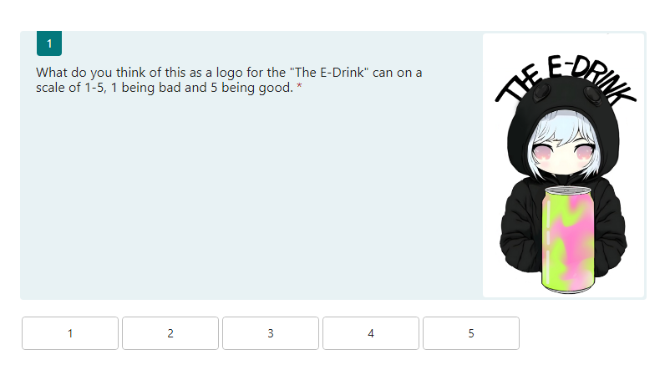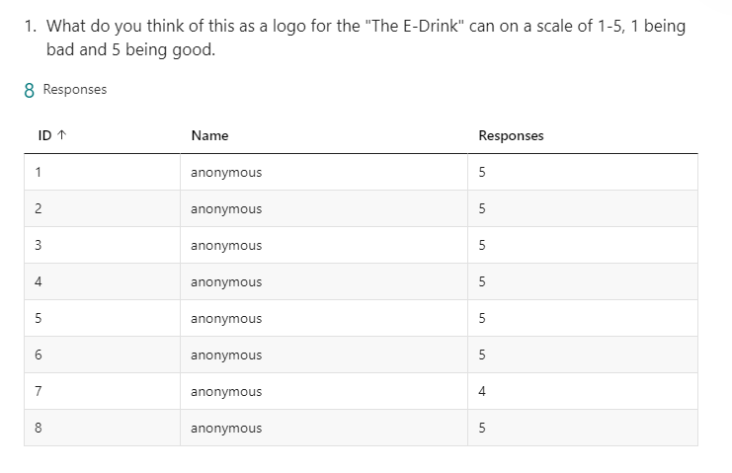

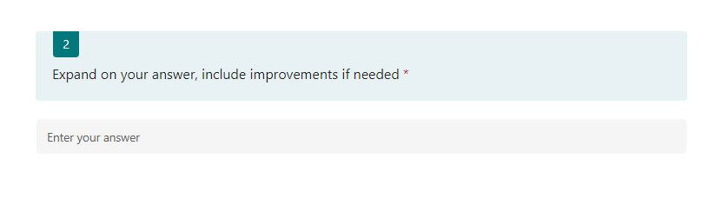

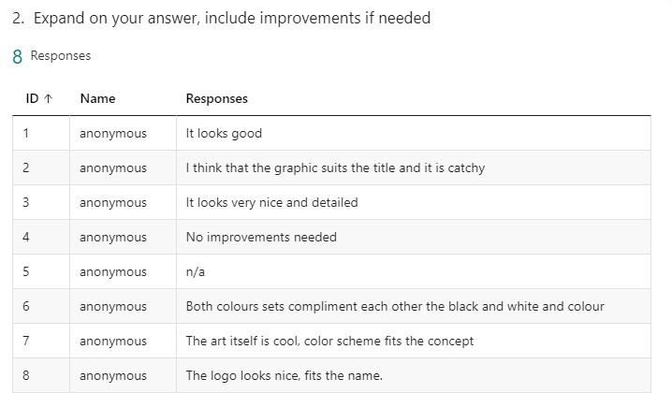

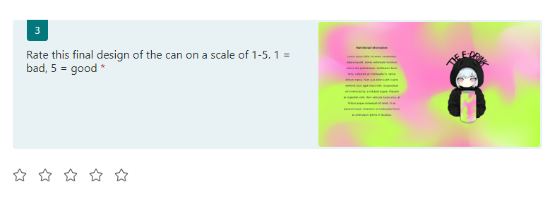

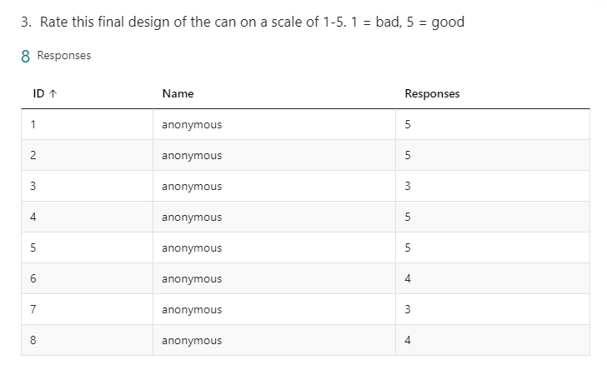

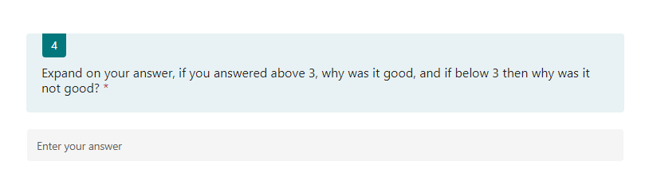

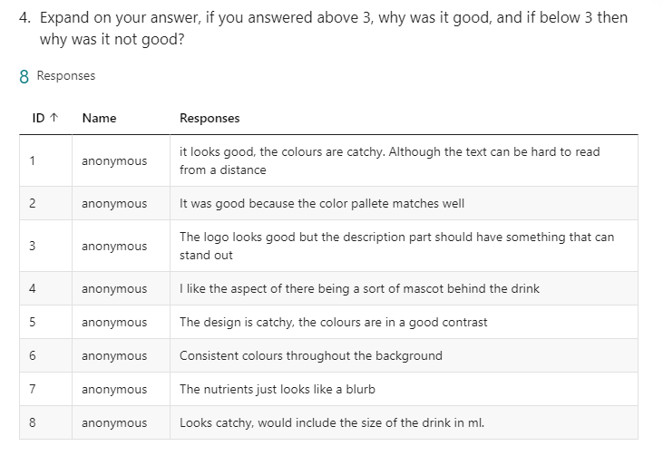

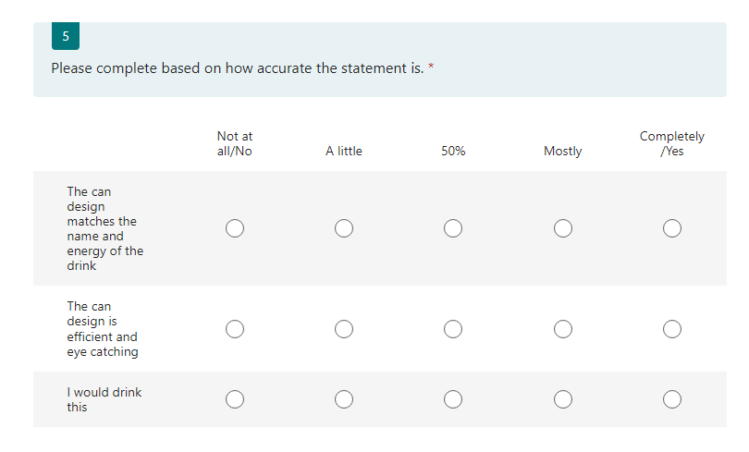

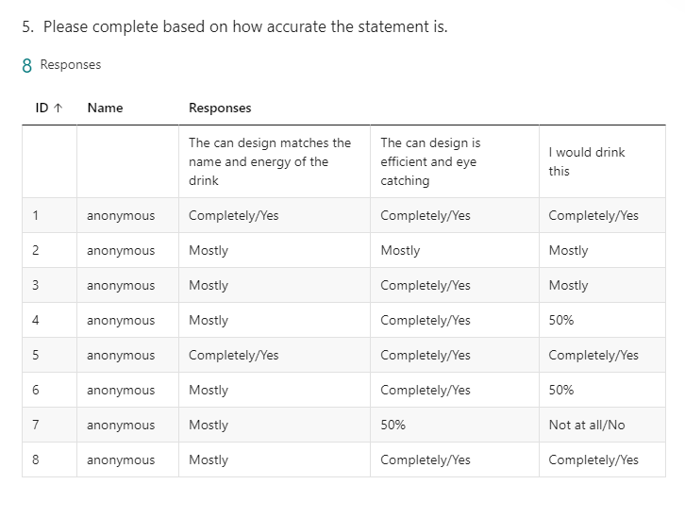

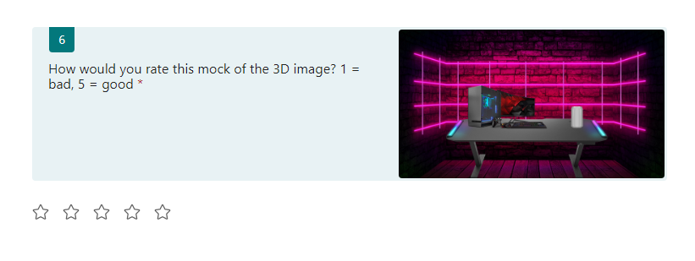

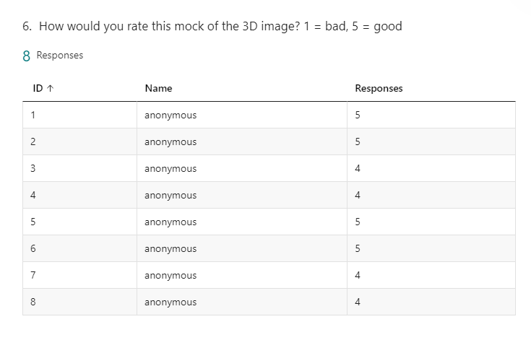

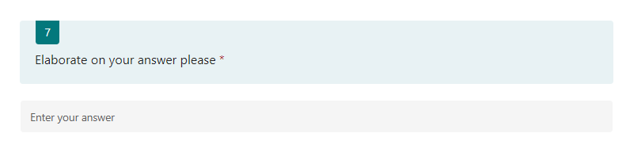

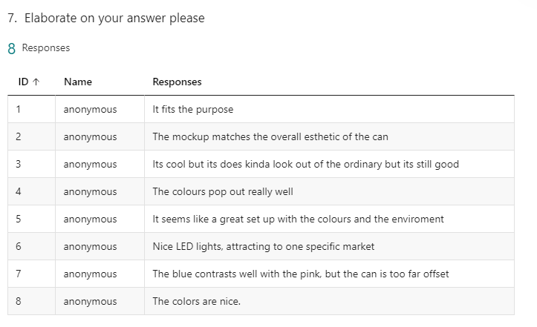

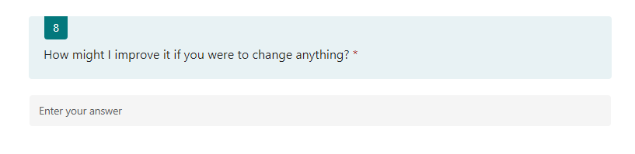

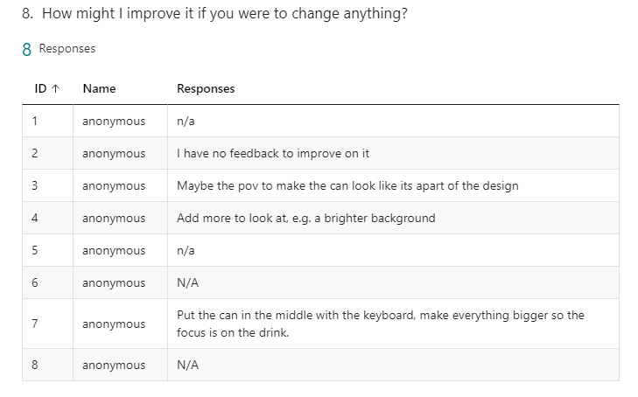

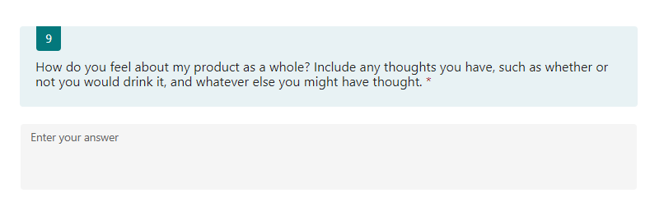

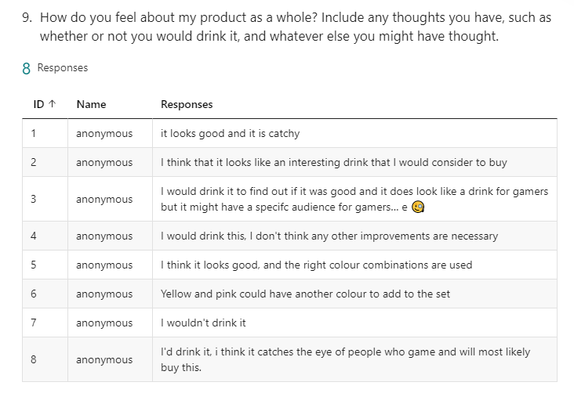

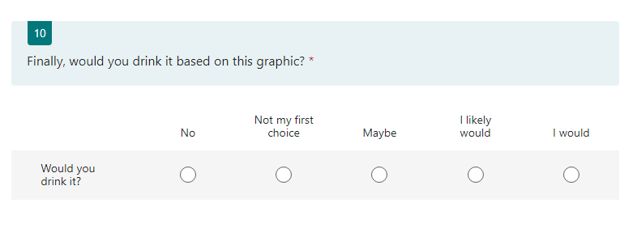

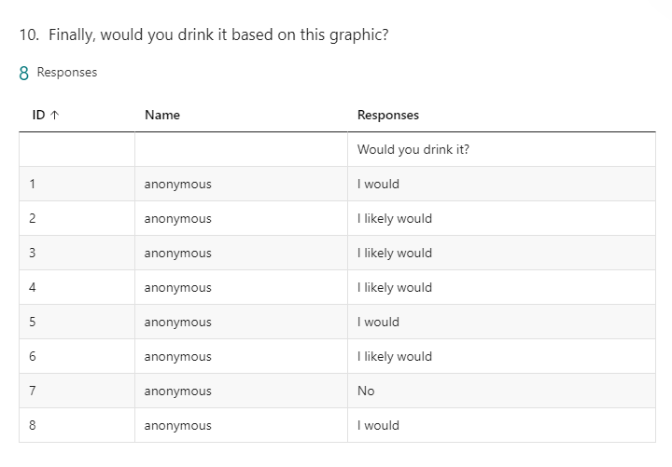

This is the feedback I received from my peers. Following this, I will be making changes to my designs based on this in order to improve the quality of my final product and this will allow for a successful project.

## Changes made based on feedback

Based on the feedback I received, I made some changes to the 2D image. First of all, I changed the design to include the size of the drink in a vertical style which is unusual and unique among other drinks. The font type for this was also Verdana with a font size of 16, and was also bold.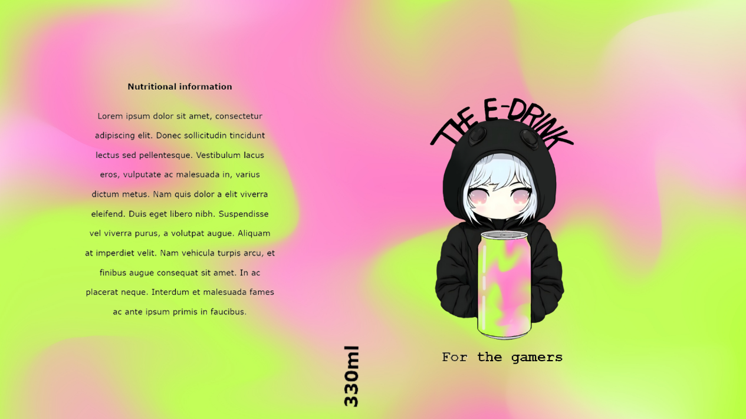

Following this, I also took to adding a slogan to the drink. The goal of introducing this slogan was to add more detail the drink, while also making it clear what the target audience of this drink was. The font type used was a monospace font, which means all the characters are equally spaced, called Couriers New, and this is because the aesthetic of monospaced fonts is unique and fits well with the design of my can.

For my 3D design, I took the advice of moving the can to the centre of the screen in order to have it be the central focus, while also including some new props like a chair to make the desk scene seem more natural. Finally, I included some additional plants in order to bring more natural life into the image and promote the idea that this drink is also naturally good for you.

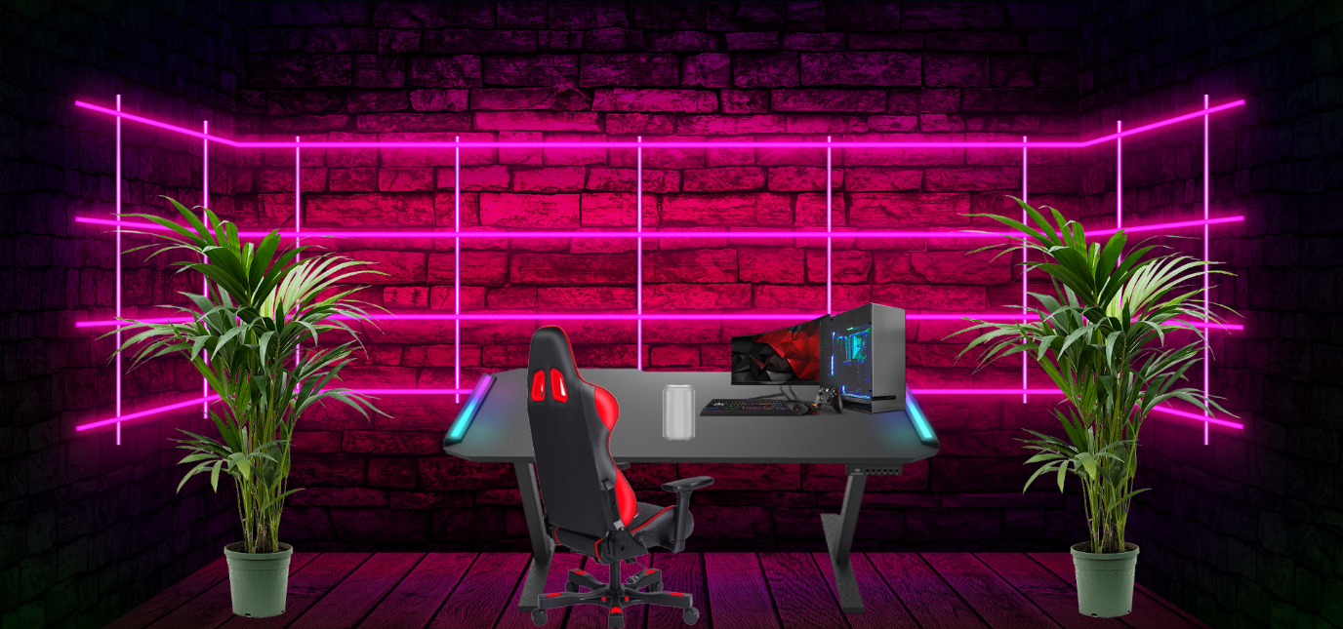

The arrows and circles display the changes made to the mock design graphic.

The new version of the 3D mock feels much livelier and more authentic compared to the prior graphic.

# Developing graphics

## 2D Graphic

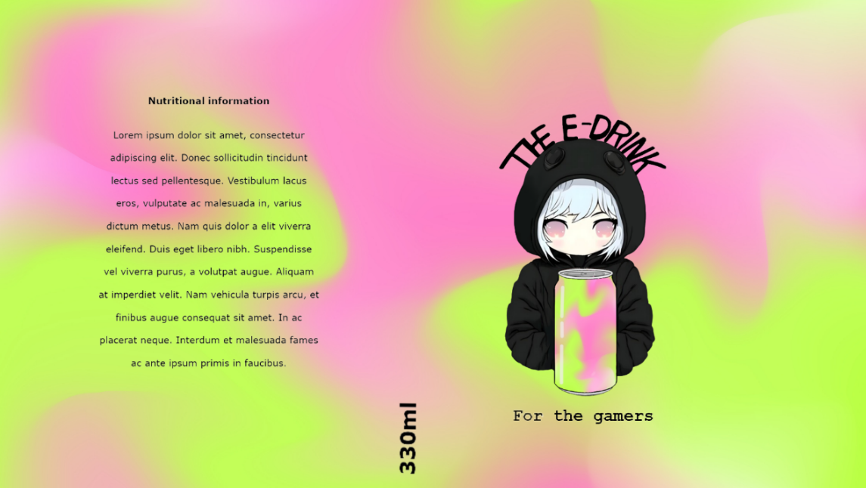Following the designs I made, I found that I was actually quite satisfied with the final result of them, and I wish to use them as is. This means that my 2D Graphic before any optimisation will be this image:

The process of developing this design was documented prior, however as a quick summary, The logo and name of the drink was hand drawn, the text on the left is written in Verdana and contains the nutritional information of the drink, alongside the size of the drink in the middle also in Verdana. Finally the marketing slogan is in Couriers New as it is a monospace font which I believe will work well.

The questions for the 2D and 3D optimisations of the graphics will be the same.

### 2D Optimisation

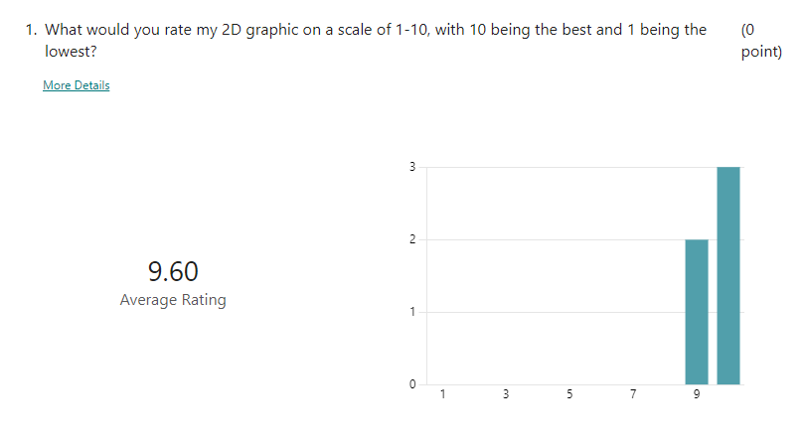

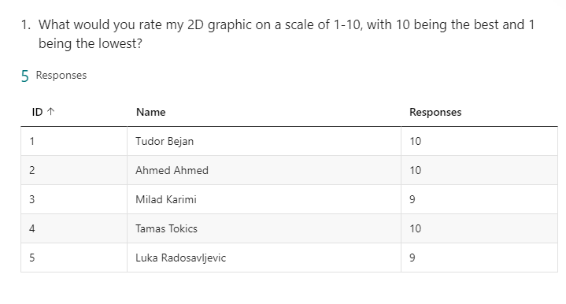

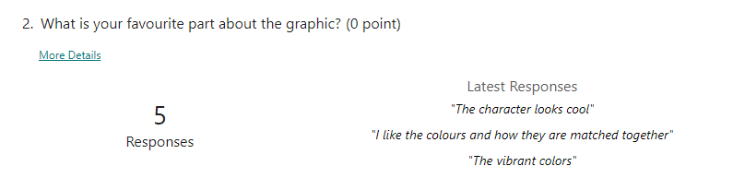

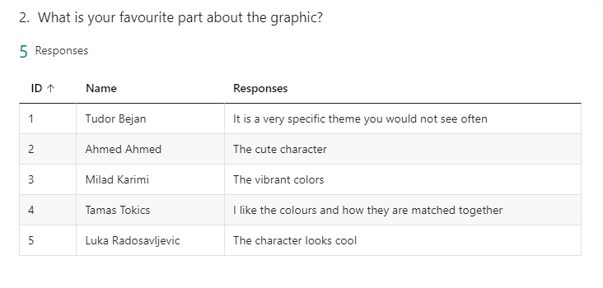

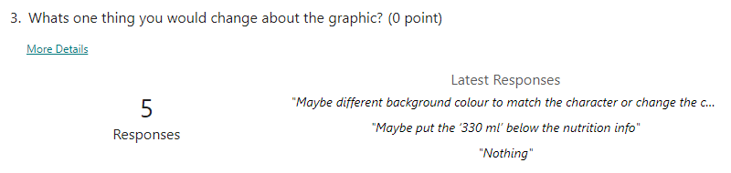

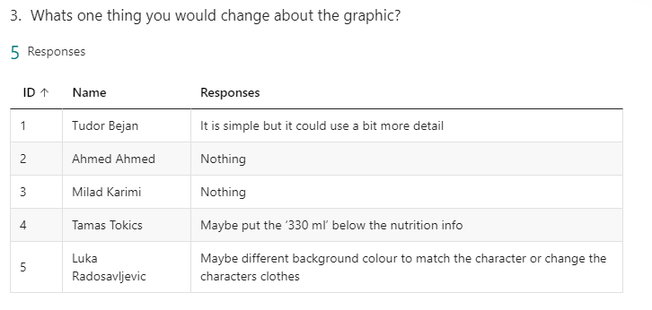

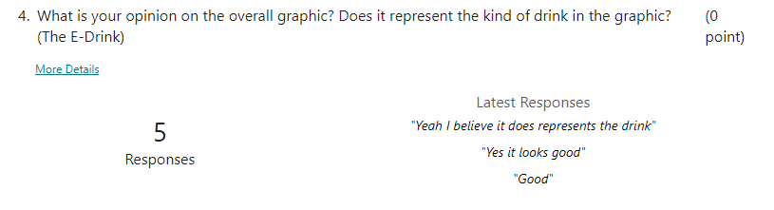

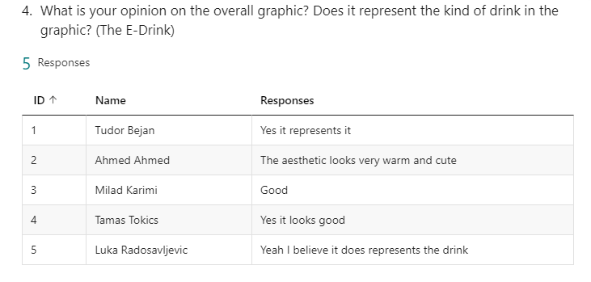

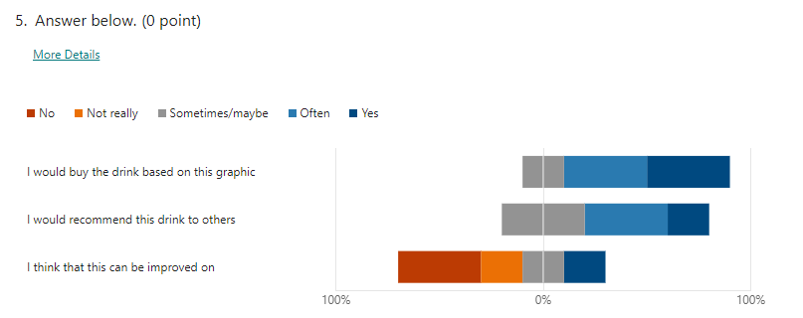

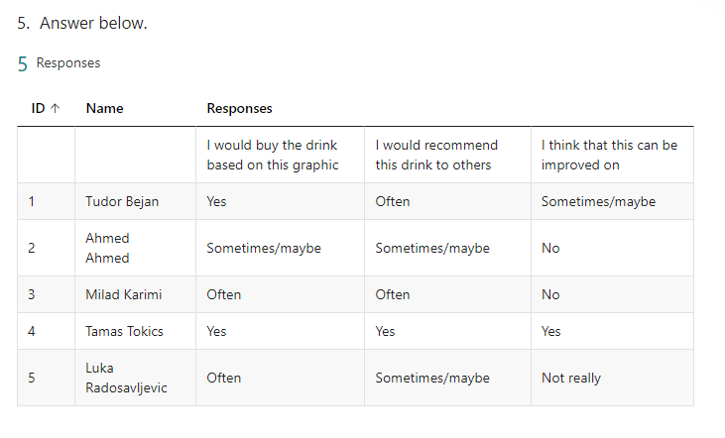

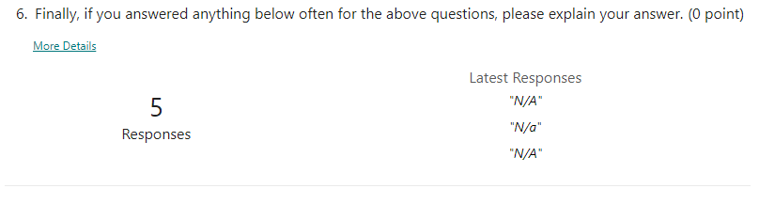

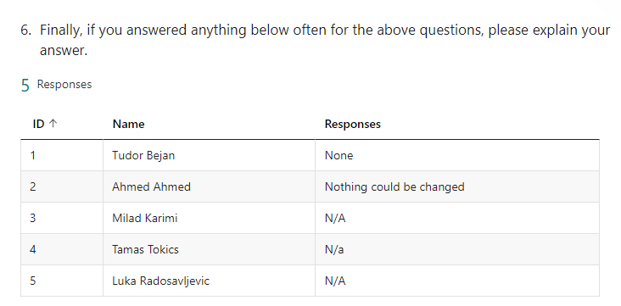

Following this feedback, I will modify the 2D Design to have the 330ml under the nutritional information, as well as having more details put on the can to help separate it and enhance the image. These changes made can be seen below:

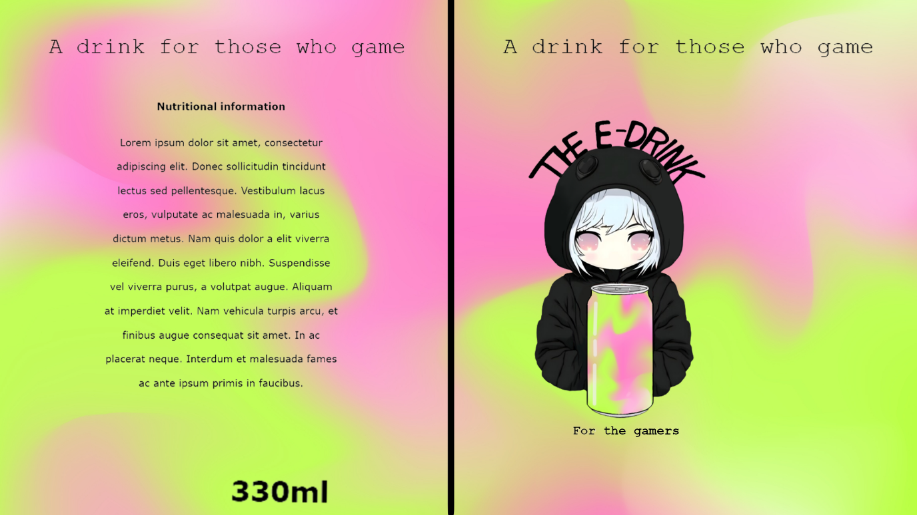

This is the final graphic. The logo is intentionally placed off centre to lead it closer to the nutritional information. I added a visible line separating the logo and nutritional information as I believe that the black and colours contrast each other very prettily. Additionally, I made the change of moving the drink size under the nutritional information, and also added a further slogan at the top that will wrap around the top of the can, reinforcing the idea that the drink is for gamers.

## 3D Graphic

Here is a list of all of the assets I have used for this 3D graphic

[Table](https://sketchfab.com/3d-models/gaming-table-2813ff817fb34e3dbfe3608fb98370b5)

[Low poly plant](https://sketchfab.com/3d-models/low-poly-style-plant-f4d845cddae04bf692bc9a9245524de1#download)

[Monitor](https://sketchfab.com/3d-models/monitor-0f3d348a29c14242bf79d0560f027af1)

[PC](https://sketchfab.com/3d-models/low-poly-gaming-computer-emapale-computate-be9cc8d7602f4f0cbbb001564eb0f7c3)

[Keyboard](https://sketchfab.com/3d-models/keyboard-low-qualty-texture-w-ppo-3e9ed4020f7f4784ae8a4bc9f65bc2b0)

[Chair](https://sketchfab.com/3d-models/low-poly-computer-chair-6148d2bbb5b041209dd3f021f476c320)

All of these above assets are allowed to be used both commercially and privately, so long as credit is provided to the original author, and these can be found by following the above links to their original download pages.

The screenshots below document the development of creating the 3D marketing scene, along with any evolutions that occur. This first screenshot was taken once the base for the image had been developed, specifically the PC, Cans that display the logo, and the table. This was a good starting point for my 3D scene to develop as it shows how the initial idea came into play, and it was just a matter of making everything fit with the final scene later on.

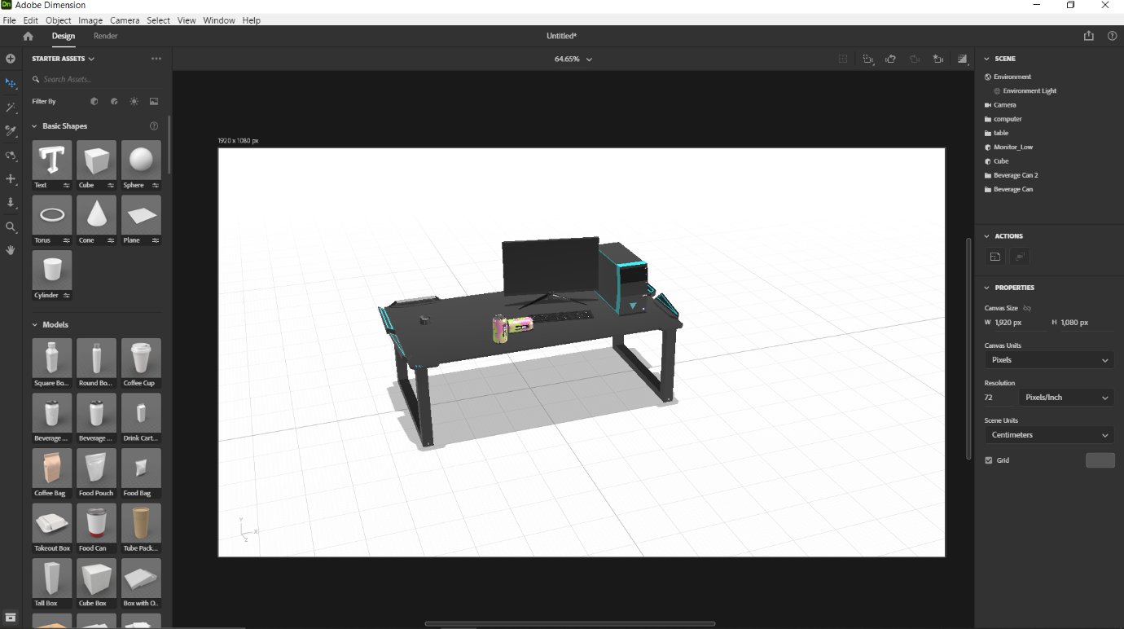

This next screenshot depicts how I had found the models I would like for my graphic for the chair and plants. These are both low poly as I wanted to keep the performance of my device in mind when creating this and so I avoided models with a high number of vertices and triangles as my laptop had struggled with these previously.

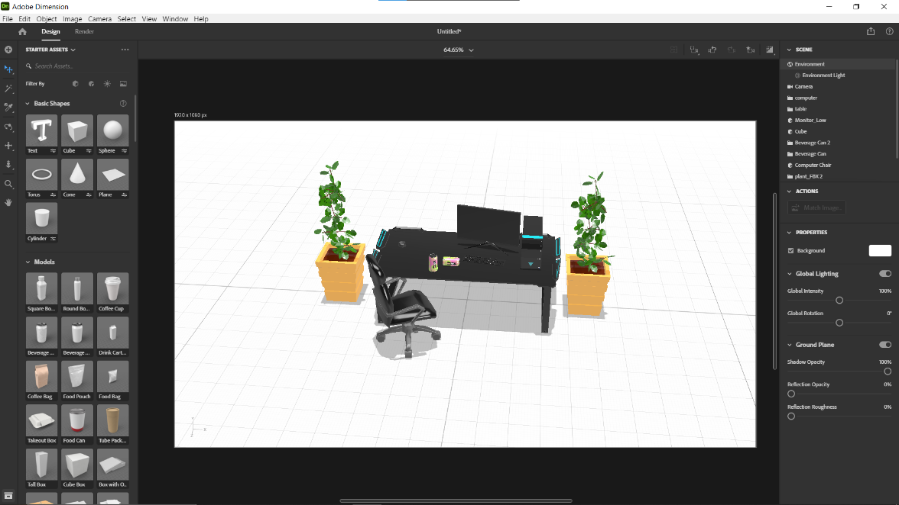

This next image depicts how I went on to implement lighting in the scene. Knowing that I was going to use a neon pink background helped me decide what colour and what intensity I should set my lighting to, and overall allowed me to successfully set up my lighting for my 3D marketing image.

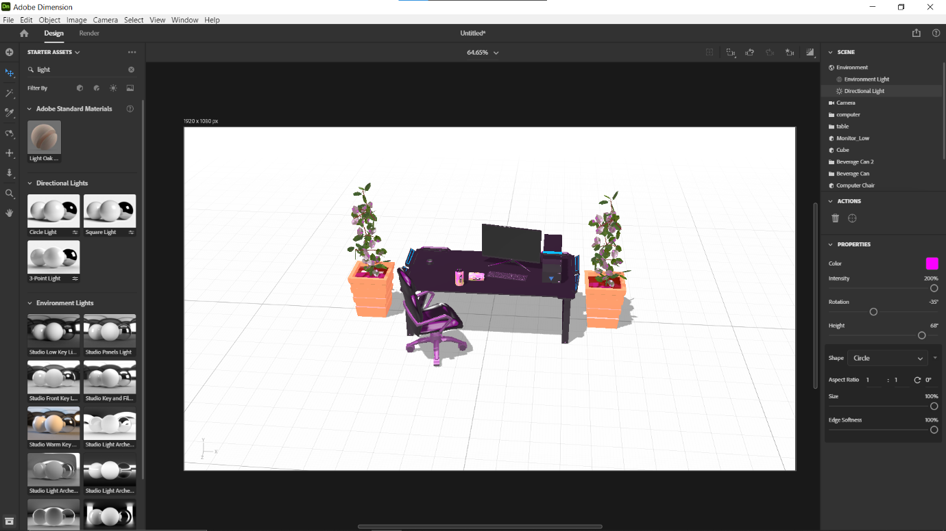

This was once the 3D background had been implemented. All of the props were not in a good position for the rendering so I took the time to reposition them and the camera for a high quality render.

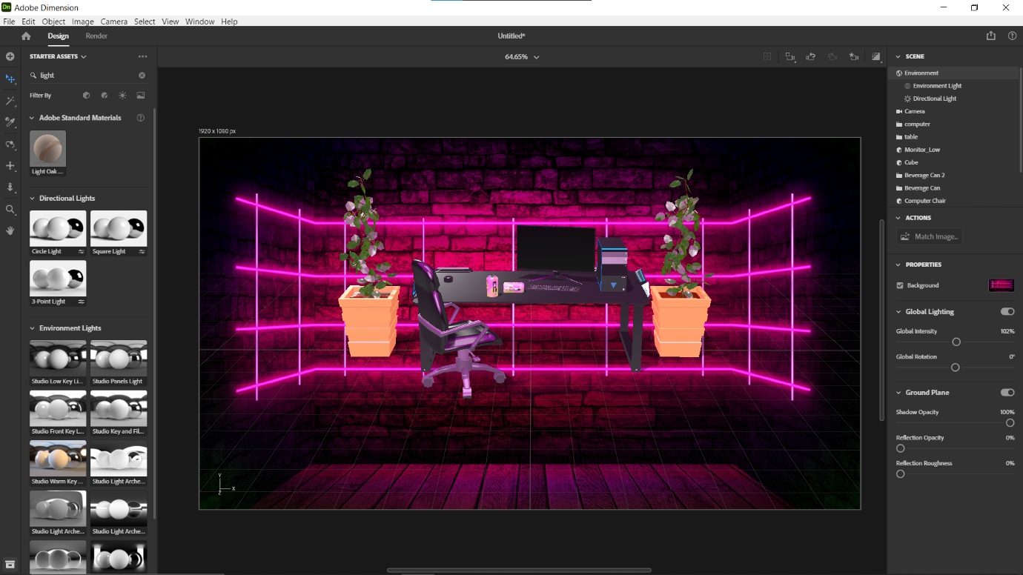

This was the finished result of my work for the 3D marketing graphic. I positioned everything as I had wanted and, after taking one more screenshot, proceeded to render.

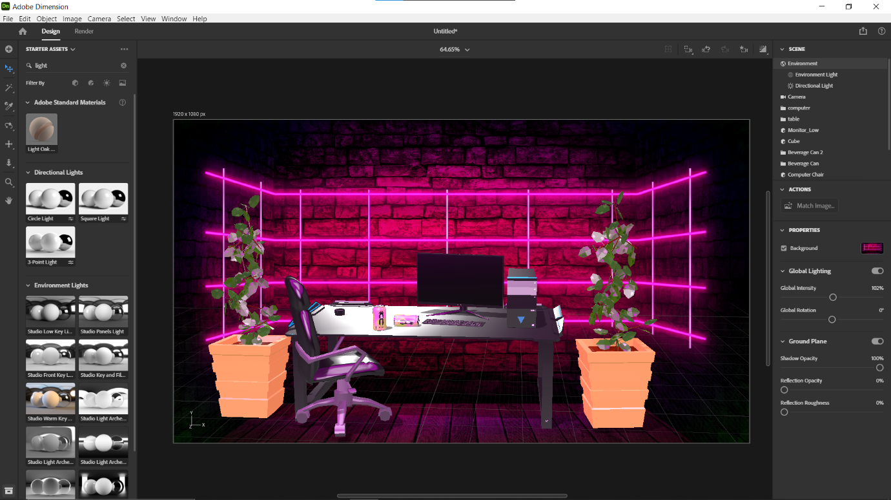

This was the last screenshot taken, simply displaying how the can drink graphic looks on the can, allowing for the viewers of the 3D marketing graphic to truly see the drink in its element.

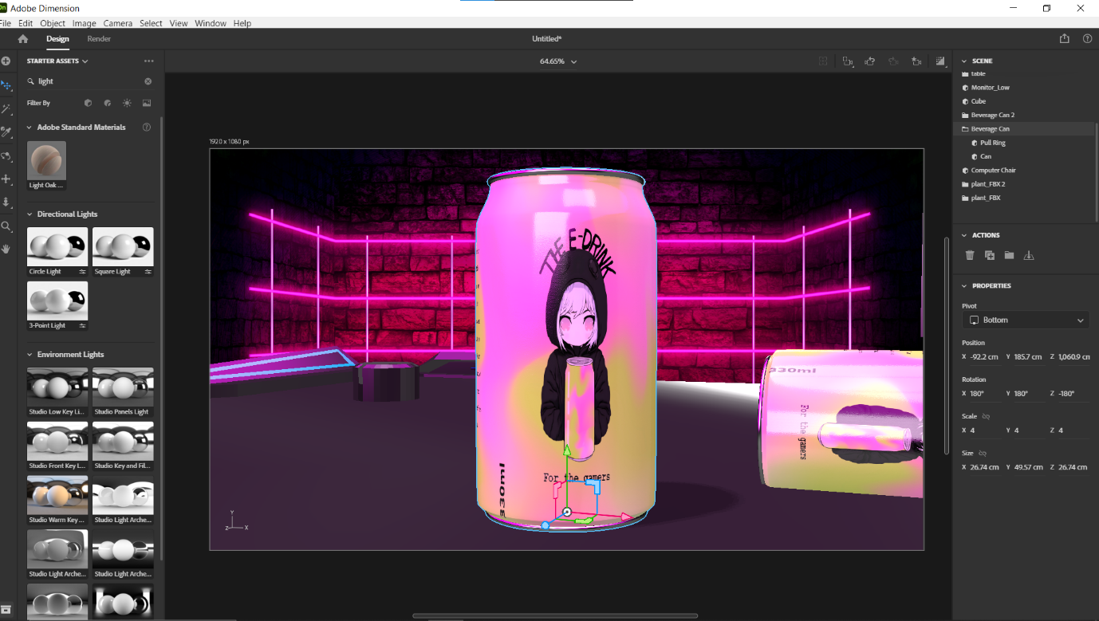

Finally, this is my 3D graphic rendered to the highest quality, ensuring that the quality is satisfactory. I made sure to include many props in order to meet the client requirements, alongside having a matching background and many other necessary themes to meet the clients requirements for my 3D marketing graphic.

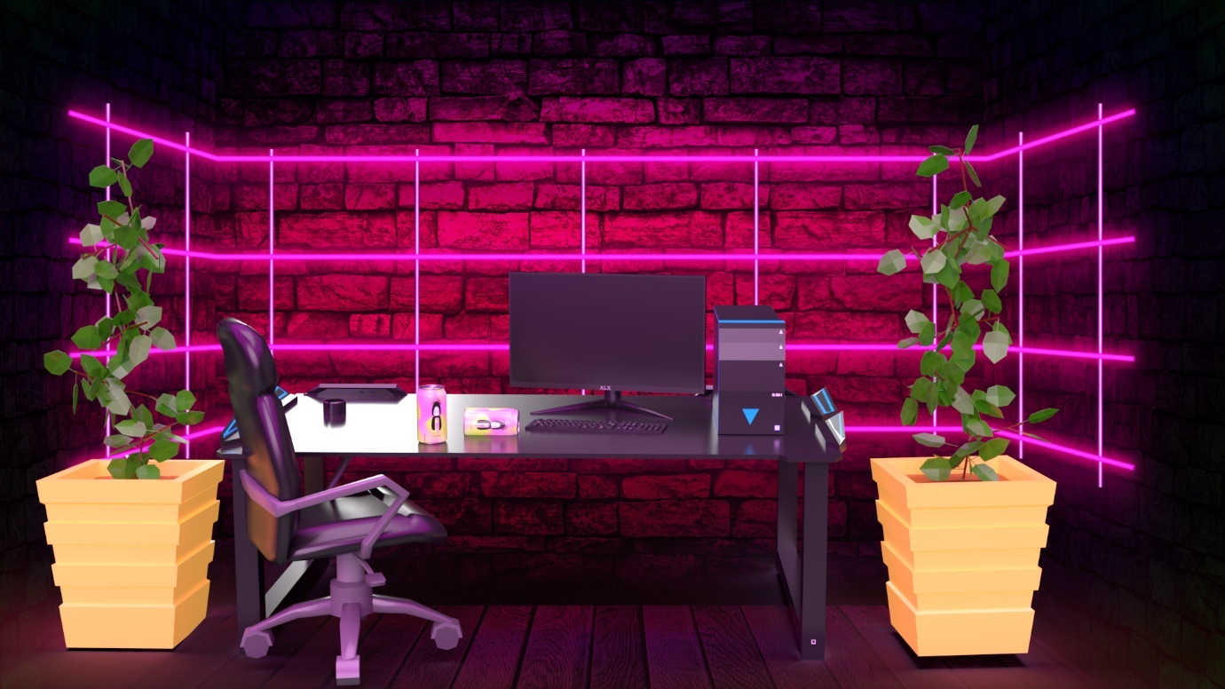

### 3D Optimisation

Below are the questions I asked and received answers for, in regard to the feedback for my 3D marketing graphic.

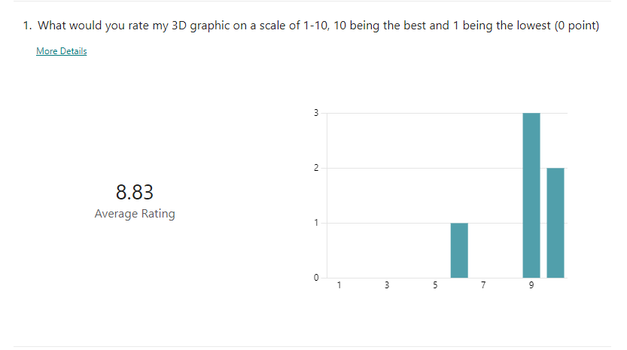

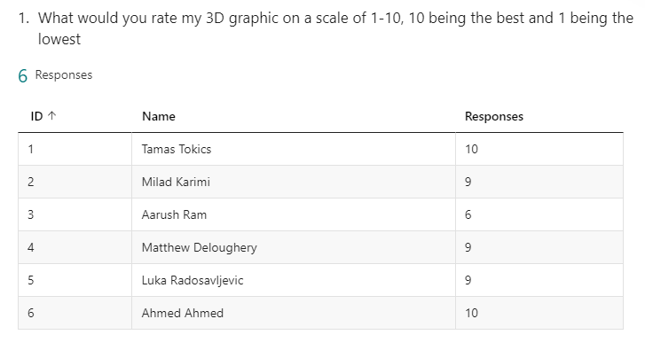

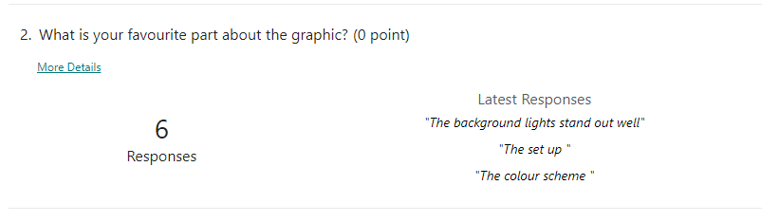

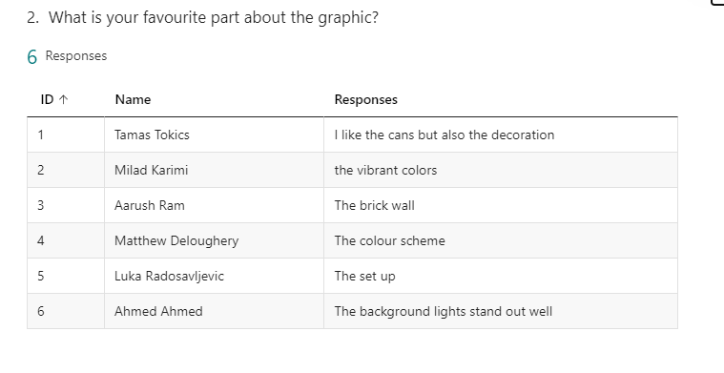

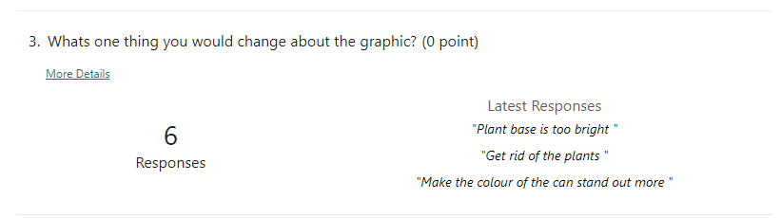

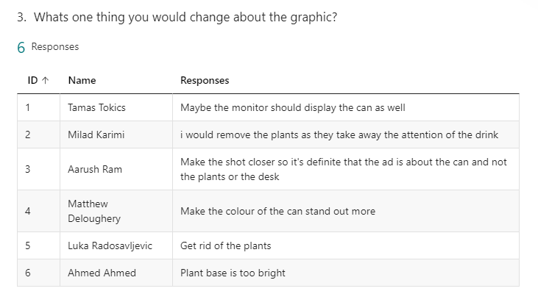

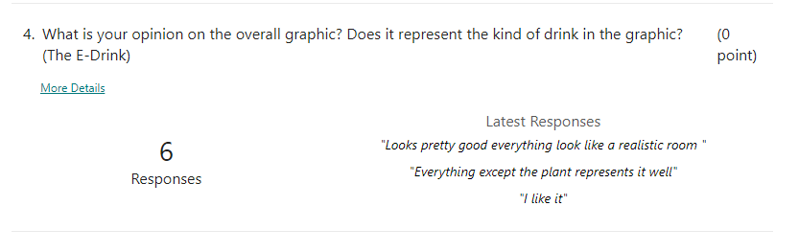

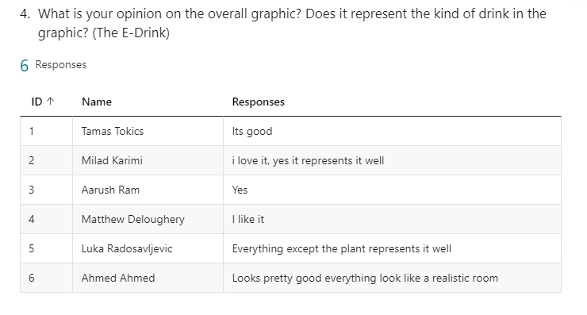

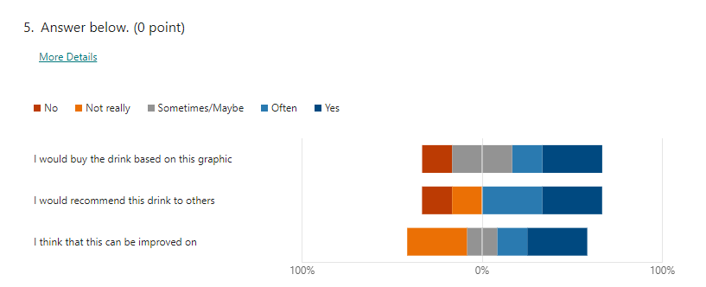

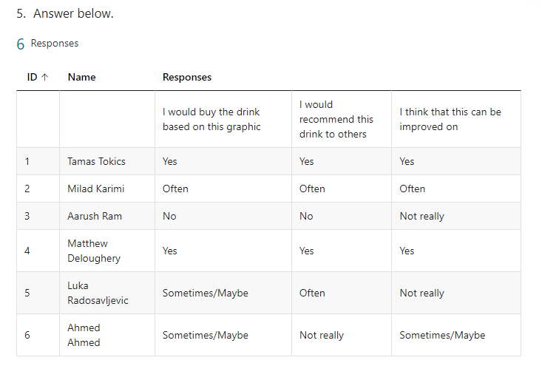

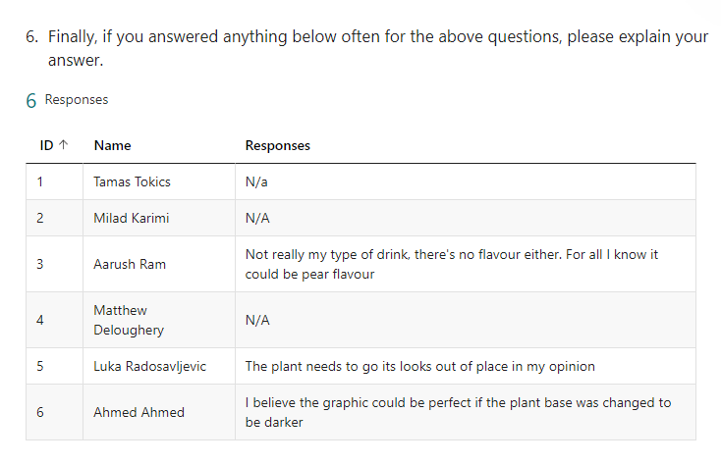

Following the feedback, a lot of focus seems to be on the plants, either how the colour is out of place or the whole plant itself is out of place, and so I believe that I will be removing them in order to enhance the visual. Additionally, I will also make the change to bring the camera closer to the can in order to cement the fact that this is an advert for the can itself, and not the whole setup.

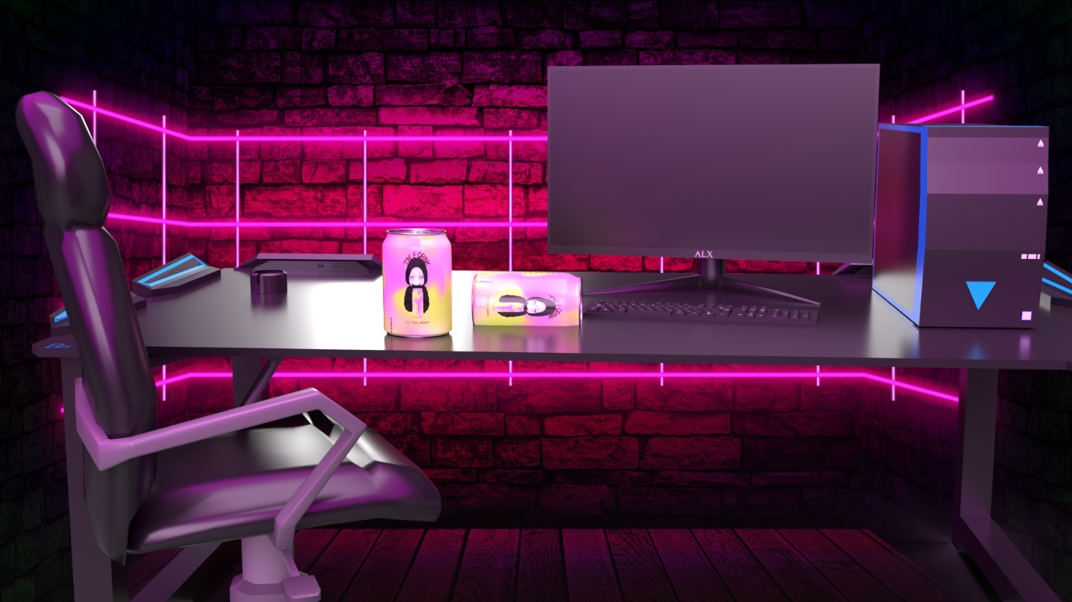

This is the final optimised graphic; I also ensured to largen the can and make sure that the focus is on it. The final product of this graphic is that there is a large focus on the can, while removing anything that seems out of place and therefore ruining the marketing graphic. Additionally, the high quality, which is shown through things like reflections on the table, is also adding to the quality of the image and raises the overall worth of the graphic.

# Evaluation of Graphics

## 2D Evaluation against brief

Throughout the journey of creating my 2D graphic, there were many design elements that I used, such as hand drawn logos and different text fonts, while also focusing on enhancing the nutritional information to be displayed easily and without difficulty to read. While receiving feedback, I focused on the changes that I had to make from it and then made sure that I implemented those changes effectively and efficiently.

In order to efficiently create the 2D graphic, I utilised the tools Procreate and Adobe Photoshop. Procreate served the purpose of designing the logo and handwritten text, which helped to providing a unique feel to my drink and separated it from other drinks. With Adobe Photoshop, I added the text alongside various design features, including the slogan and drink size, all of which are essential for a successful beverage. Procreate and Photoshop together enhanced my workflow, enabling me to achieve a successful 2D graphic that captured the theme of the drink with its distinctive logo and text, achieved by various brushes, an intuitive interface, and text tools in Adobe Photoshop.

Procreate and Adobe Photoshop both helped immensely in creating a successful product, by improving my workflow, the designs quality, and the overall final product. Procreates intuitive interface and variety of brushes allowed me to explore different artistic opportunities for the logo and name and ended up providing a satisfactory aesthetic for my drink. Following that, Photoshop provided the tools in order to mould everything together and allowed me to add features like the nutritional information. The combined use of these tools resulted in a successful 2D graphic that enhanced the visual appeal of the drink, and overall these two aided to streamline my workflow. The increase in quality is clearly visible in the end compared to the initial design and displays a distinctive 2D graphic for the assignment.

Over the course of the project, I used a variety of skills and techniques that enabled me to create the successful 2D graphic. There were several skills that I relied on, but one skill that I relied heavily on was graphic design, which involved the following skills:

* Principles of composition
* Colour theory
* Typography

I had experience with these skills prior to working on this graphic, and over the course of this assignment I gained the opportunity to hone my ability to apply these skills. Furthermore, the use of Procreate and Adobe Photoshop enabled me to use the large arsenal of skills I have regarding graphic design, and expanded on the ideas that were now technically possible that were limited prior to this. Finally, I developed my attention to detail, and ensuring that the graphics were fully accurate, such as text and logo placement, was crucial and this honed my focus on the detail. Overall, this assignment has served as a position for me to apply and improve my skills regarding graphic design

I received valuable feedback on both my initial design and finished graphics. The feedback showed a variety of areas for improvement, including placing the 330ml below the nutritional information for better readability. Additionally, suggestions were made to add more detail to enhance the overall design.

To address the feedback, I made specific changes to my work. I repositioned the 330ml below the nutritional information, ensuring clear information presentation. To add more detail, I refined the logo by incorporating different elements and adjusted the overall composition to create a visually pleasing design. Additionally, I separated the logo and information using a distinct line, showing a clear separation between the two. Incorporating the feedback also led me to add a slogan across the top, further enhancing the brand's messaging. The impact of the feedback was significant as it heavily influenced the final outcome of the project. By implementing the suggested changes, the design became more refined, detailed, and effectively conveyed the desired message of the brand, an energy drink for gamers. Overall, the feedback played a crucial role in refining and elevating the quality of my finished graphics, resulting in a more successful and impactful final outcome.

Throughout the project, I successfully implemented a number of design elements and techniques to create an appealing 2D graphic. By using hand-drawn logos, a range of text fonts, and an improved nutritional information display, I achieved a successful outcome. The feedback I received on my initial design and finished graphics highlighted specific areas for improvement, such as placing the 330ml below the nutritional information for better readability, adding more detail, and creating a clear separation between the logo and information. To resolve the feedback, I made many changes, including repositioning the 330ml, adjusting the logo, and adding a distinct line to separate the logo and information. These adjustments enhanced the final outcome of the project, resulting in a polished design. The positive feedback from peers showed the success of these improvements. Additionally, my proficiency in graphic design principles, played a crucial role in achieving the desired quality. Overall, the involvement of feedback and strategic decision-making contributed to the successful outcomes of the project, showcasing my ability to adapt and refine my work based on constructive criticism.

Upon reflection, there are a few areas of improvement that I identified in the project. One aspect that could have been better is the level of detail in the background. Although I received feedback, nothing focused particularly on the background and I believe that there could have been some changes made to this, that would have helped to enhance the graphic. Additionally, I realised that I could have explored more diverse colour schemes and ideas, rather than deciding on one idea and only sticking with that.

If I were to do the same project in the future, I would choose to approach it from a more structured timeline with a stricter schedule and work on constant improvements, taking ideas from all areas, and not just sticking with the same idea constantly. Additionally, I would seek feedback sooner as this would allow me to understand whether or not the idea I have is plausible and has the potential to be successful. Overall, I learned about the importance of actively seeking feedback in order to improve upon my work by incorporating it into my designs sooner and more efficiently. Additionally, I learned about the limitations of working with one idea and remaining narrowminded, and that there should be a wide range of ideas available to aid in creativity and freedom with the designs.

I believe that I have met the requirements of the client brief by creating a visually attractive design and graphic that fully communicates all of the needed information from the can to the consumer, both through the colour schemes of the can and the actual information on the can. Furthermore, I have clearly shown effective creativity, individual responsibility, and self-management skills by incorporating feedback and making decisions on design elements. I also made sure to use appropriate technical language and consistent grammar and spelling throughout my documentation.

Finally, I would state that I am satisfied with the final product of the 2D graphic, and that it completes its job effectively.

## 3D Evaluation against brief

Throughout the process of creating my 3D graphic I have used many available graphics, ranging from desks, pcs, to even plants. These were all allowed to be used for both commercial and private usage as long as there was credit given to the original author which I have provided in the forms of links that provide access to the original download links.

My design process for my 3D graphic began with the initial development of the scene, such as just the table and can, followed by feedback on my work on how to improve. This allowed me to make the necessary changes to improve the quality of my work and focus on enhancing the final product. I evaluated my 3D graphics against the brief and requirements and following this I believe that I have met their needs by focusing on the can as the main subject, ensuring a high-quality image with appropriate reflections on the table, and removing anything that seemed out of place. I also made sure to use appropriate technical language and consistent grammar and spelling throughout my documentation.

To create my 3D dimensions design, I used the software Adobe Dimensions. This is a powerful software tool specifically designed to create 3D mock up images, and offers intuitive UI, alongside integration with other Adobe technologies, which will be relevant in the future. Through importing the 2D graphic, from Adobe Photoshop, I was able to make the most of the features that Adobe offers and was able to smoothly put the can design onto a metal can. Furthermore, Adobe Dimensions also provided me with many powerful features like lighting, texture, and material manipulation. As a result, using Adobe Dimensions as the choice enhanced the 3D representation of the can, and this enhancement would only further translate into making a better graphic overall with the numerous props. Finally, the built in 3D props and 3D props online helped save time in the development process of the mock up.

The use of Adobe Dimensions also helped to elevate the quality of my assignment by increasing the realism of the 3D design. Adobe Dimensions ability to manipulate a number of features in the 3D scene, like lighting, allowed me to accurately display the brand and aesthetic of my can, i.e., through purple/pink lighting. As a result, I was able to effectively communicate my design in the 3D graphic in a professional manner. Finally, Adobe Dimensions also enabled me to adequately facilitate my workflow, enabling me to work efficiently and at a high level, while also working at a fast enough pace to not fall behind. Finally, its integration with other Adobe products also aided in streamlining my workflow and allowed for a satisfactory final product. Overall, Adobe Dimensions as a tool was crucial in order to make this a successful project and enhanced all aspects of the development.

Throughout the process of the 3D aspect of the project, I utilised several skills that enabled me to bring my 3D mock up to life. One of the main skills I utilised was 3D modelling, which involved creating the 3D structure of the can and other props. This skill was acquired through previous experience with 3D software and further improved during the assignment as I experimented with different modelling techniques and approaches. Another aspect of the project was texture mapping, where I applied the 2D graphic onto the 3D model of the can. I honed my texture mapping skills by studying tutorials, exploring different mapping methods, and fine-tuning the textures to ensure accurate representation of materials like metal and labels. Finally, lighting also played a vital role in the development of the 3D mock up, and the abilities to maximise the use of the light were put to the test. I had to learn to manipulate light sources, adjust their intensity and colour, and position them strategically to highlight the important elements of the design. These skills were achieved largely though the use of trial and error, in order to figure out what worked and what was unsuccessful, and then combining that experience with tutorials online.

One significant challenge I faced was capturing precise reflections and shadows to ensure the realism of the 3D design. It required meticulous placement of light sources, adjusting their properties, and changing minor scene settings. Through research, experimentation, and iteration, I was able to achieve the desired results, refining my skills in 3D modelling, texture mapping, and lighting. This project provided insights into advanced rendering methodologies, lighting techniques, and shading, improving my ability to create visually appealing 3D designs and laying groundwork for future projects.

The feedback received on the initial design and finished graphics included suggestions to remove the plants as they were deemed distracting and drew attention away from the drink. Additionally, there was a request to make the shot closer to the can in order to create a stronger focus on the product. Another feedback was to eliminate the plants entirely.

To address this feedback, changes were made to the design. The plants were removed from the mock up to ensure a clear presentation of the drink. The shot was adjusted to be closer to the can, creating a more engaging experience. The decision to remove the plants altogether was introduced and implemented, resulting in a design that emphasised the drink as the main focal point. The impact of this feedback on the final outcome of the project was significant. By incorporating the suggestions and making the necessary adjustments, the design became more streamlined and focused on the drink itself. The removal of the plants allowed for better visual hierarchy and emphasized the product, enhancing its appeal to the viewers. The closer shot of the can intensified the connection between the viewer and the product, creating a more impactful and enticing representation.

Overall, the feedback played a crucial role in refining the design and improving its effectiveness. By addressing the suggestions and making the changes, the final graphics achieved a stronger impact and successfully conveyed the desired message of the drink, a drink for gamers.

Throughout the process of creating the 3D graphic, there were a number of aspects that aided in the successful creation and completion of the project. One part of the project that was instrumental in completion at a high level, was Adobe Dimensions. Its intuitive UI and integration with other Adobe technologies allowed for a seamless workflow and enhanced the 3D representation of the can. The availability of built-in 3D props and online resources also saved time in the creation process, ensuring efficiency. Furthermore, the feedback received from others about the success of the mock up and the designs also aided in validating the success of the project. With the feedback highlighting the quality of the scene that was achieved through the manipulation of lighting, texture mapping, and 3D modelling techniques. The use of purple/pink lighting effectively communicated the brand and aesthetic of the can, while the removal of distracting elements like plants created a professional design.

A number of skills were vital for ensuring that the project was a success:

* 3D modelling
* Texture mapping
* Lighting and rendering
* Composition and Framing
* Colour theory
* Attention to detail
* Creativity
* Feedback and communication

One significant challenge faced during the project was capturing reflections and shadows to maintain realism. Through iteration, the necessary skills to resolve this were acquired and this problem was solved. Overcoming this challenge improved the quality of the 3D design and enhanced the overall mock up.

In reflecting on the project, there are areas that could have been improved. One aspect that stands out is the initial composition and placement of elements. Taking more time to carefully consider the arrangement of objects and their visual appeal would have resulted in a more focused mock-up. Additionally, gathering feedback earlier in the process and involving others in the decision-making would have allowed for more iterative improvements and a better understanding of the audience's perspective.

In future projects of a similar nature, I would make several changes based on the lessons learned from this experience. Firstly, I would prioritise seeking feedback early on and involving others throughout the design process to ensure other opinions are considered from the outset. Secondly, I would set more time aside for experimenting with different lighting scenarios and texture mapping techniques to get a better-quality final graphic. Lastly, I would focus on clearer project planning, setting specific goals and timelines, to enhance efficiency and avoid unnecessary delays, as this was something that I found impacted my graphics.

Furthermore, I have consistently demonstrated creativity, individual responsibility, and self-management skills as I combined the different parts of my graphics. I also . I also optimised my graphic product by using a wide range of techniques while evaluating and justifying my decisions throughout the design and development process.

Finally, I believe that I have completed this aspect of my graphics, both in design and development, effectively and up to the required standard from the client.